Installation
and
Configuration Guide
 |   PointMatter |   VERSION 1.0
 | Reporting Solution

Table Of Content

About PointMatter 4
Overview 5
System Requirements 5
Required Permissions 5
Installation and Configuration Steps 5
PointMatter Installation 6
Prior to Installation 6
PointMatter Setup Program Installation 6
PointMatter Application Installation 8
PointMatter Application Configuration 12
Tenant Configuration 12
Tenant Setup 12
Source Setup 15
Gateway Setup 18
SMTP Configuration 20
PointMatter Portal Configuration 21
PointMatter Template Manager 22
Template Configuration 22
Template List 24
Template Deployment 24
Status 26
Appendix 28
System requirement for PointMatter version 1.0 28
PointMatter Installed Side by side to Compass Server 28
PointMatter Installed on a Standalone machine 30
Web Server(IIS) Role Services 31
General Requirements 31
Account Requirements 31
Desktop Client 32
List of Prerequisites 32
Enabling Internet Information Services (IIS) 33
Enabling IIS on Windows 10 33
Enabling IIS on Windows Server 2012 and 2016 34

About PointMatter
PointMatter is a software platform that provides reporting solutions for Compass and BACnet-compliant Building Management Systems (BMS). PointMatter Reporting Solutions (PRS) is designed using modern frameworks such as DotNet Core and Angular 8. It runs on Microsoft’s Windows operating system.

This version of PRS supports the Alerton Compass BMS. PRS gives Compass operators the ability to report and analyze the performance of their building automation system (BAS). PointMatter communicates with the BMS database to sync with key BACnet-compliant objects such as Points, Devices, Alarms, Energy and Trends for reporting purposes.

The PointMatter platform contains several components that work together to provide a unified reporting solution for the BMS. The components are:
- PM Installer - This is the setup package that gets installed on the Compass server
- PM Manager - Installation and Configuration of Tenant/Site, SMTP and Gateway and data sync settings
- PM Portal - Is the web application that end users can log into to run reporting and add-on applications. PM Portal is the subject of this document
- PM Template Manager - PRS Admins utility tool to
  - Install, configure and deploy custom report templates
  - Configure default parameters for report templates (header, footer and reports repository path)
  - View all deployed templates and ability to download the report template RDL file.

Overview
This document provides the steps to install and configure the PointMatter Reporting System on an on-prem computer.

Please read the Release Notes for important information about this release. When you are finished with the installation, refer to the PointMatter User’s Guide to learn how to use PointMatter Reporting.

System Requirements
Important: Review system requirements in the Appendix section prior to starting the installation.

Required Permissions
To complete the installation you must have administrator privileges on the computer that will run PointMatter and you must be able to create a read-only user on the SQL Server that is used by Compass.

During the installation you will run the installation program as a Windows administrator.

During the configuration of PointMatter, you will need to enter the sysadmin credentials of the SQL Server that is used by Compass. This is used to create a service user with read-only permission on the Compass database. This user will be called “pmuser”.

Installation and Configuration Steps
These are the steps to install and configure PointMatter:
- Download and install the PointMatter Setup Program
- Run the PointMatter Setup Program to:
  - Install PointMatter on your computer
  - Configure PointMatter
    - Tenant Setup
    - Source database access
    - Gateway & SMTP settings
    - Data collection schedule
- Launch and use PointMatter

PointMatter Installation

Prior to Installation
Ensure you have the following prior to starting this installation:
Installation package
The installation package will be provided to you by LogicMatter.

License Key File
A license key will be issued to you by LogicMatter.

Alerton: The PointMatter zip file you downloaded has a directory tree. Look in the “License” folder for the file called pointmatter.lic.

Required Privileges and minimum system requirements
The user who is installing PointMatter must have admin/installation permissions on the computer system. Your computer system must meet the minimum requirements for installation. See Appendix for system requirements.

PointMatter Setup Program Installation
Step 1: Download the installation package from the provided download link

Step 2: Unzip the Installation package
Documentation is in the “guides” directory. Release notes are in the root directory of the installation package.

Step 3: Change to the “setup” directory of the installation package. Right-click on the “PointMatter Setup 1.0.x” installation application

Step 4: Right click on the PointMatter Setup program and select “Run As Administrator”
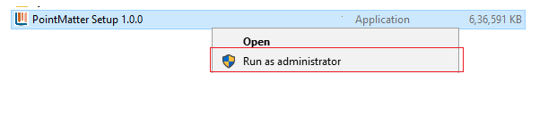

Step 5: The PointMatter Setup program will start. The first step is to choose the Installation Folder Path
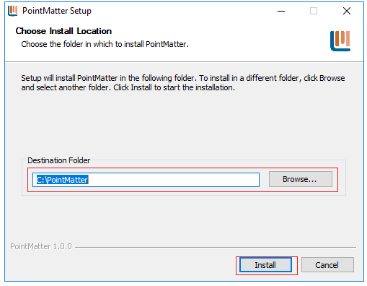

Step 6: Click on “Install” Button. This will install the PointMatter Installation and Configuration App and put a PointMatter icon on the desktop.

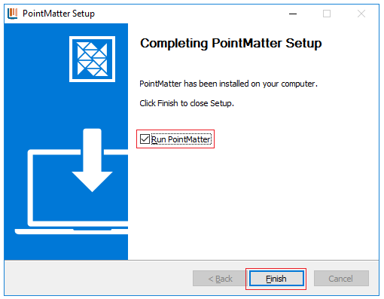

Step 7: Click on the “Finish” button. If you check the “Run PointMatter” checkbox, the PointMatter Installation and Configuration App will automatically start. You can run the Installation and Configuration app later by right clicking on the PointMatter icon on Desktop and selecting “Run As Administrator”.

Step 8: Run the PointMatter Installation and Configuration App to continue with the installation.

PointMatter Application Installation
The PointMatter Installation requires a restart of the Windows OS. During the PointMatter installation, Microsoft SQL Express is installed. The restart is required to complete the installation of SQL Express.

Follow these steps to install PointMatter as an administrator:

Step1: If you are continuing from the previous steps, you should already be running the PointMatter Installation and Configuration App. If not, Login to the machine where you have the “PointMatter Installation and Configuration App” installed and run as administrator.

Step 2: Click on Continue with Installation

Step 3: PointMatter performs pre-checks on the Windows computer before proceeding further with the installation process. These checks include:
- If system is due for Restart because of any installed/pending Windows updates
Alerton: This step does not “Restart the Computer”. It checks to see if a restart is required to complete a Windows update. If a restart is not required, this step will show as Pass. We will rename this test.
    - If “Restart Computer” shows “Pending”, restart the computer and then restart the PointMatter Configuration App after the reboot.
- If Internet Information Services (IIS) features are not enabled
    - If IIS features are not enabled and it is not running in the PointMatter Hosting System, the user needs to enable the IIS (refer to Appendix - Enable IIS section).
Example screen with IIS not setup:
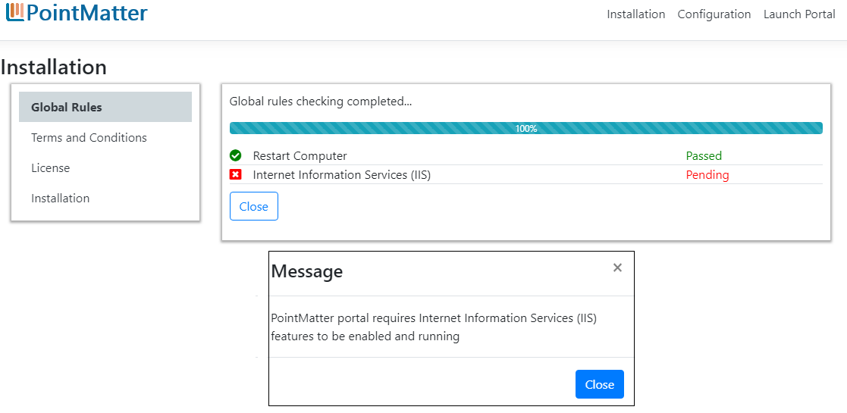
Once the pre-install checklist is complete, Press the Continue button:

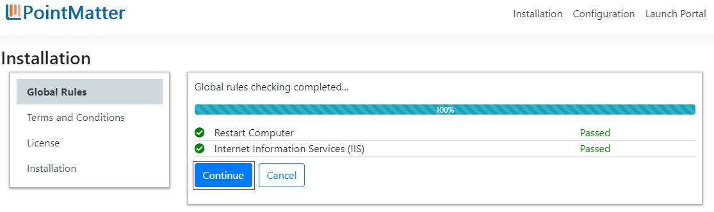

Step 4: The setup program will now step through the installation. Terms and Conditions is the next step.
Read the End User License Agreement (EULA), Select the “Agree and Accept” option and select the “Continue” option.

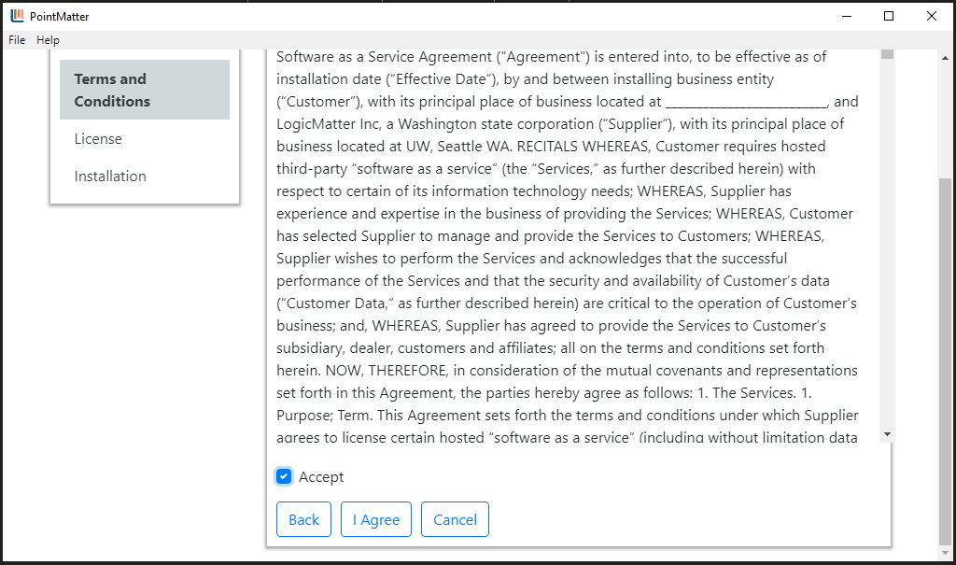

Step 5: License Validation screen

- Choose the License file(pointmatter.lic) provided by LogicMatter provided in the package
Alerton: The PointMatter zip file you downloaded has a directory tree. Look in the “License” folder for the file called pointmatter.lic. Note: this version is only “On-premise” and “Single Tenant”. These are pre-checked.
- Press the “Submit” button.
- If it's a valid license, the application will allow you to move to the next screen.

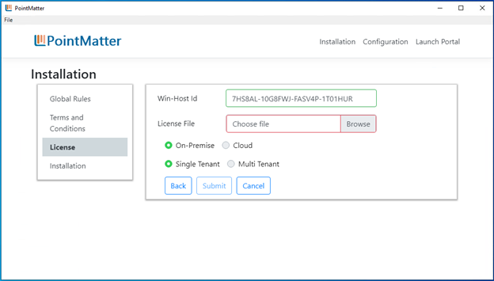

Step 6: Installation Screen
After Successful license validation, PointMatter installation will start. During the installation process, the application will
- Install Required prerequisites if not already installed on the system.
Alerton: This step may take between 5 and 10 minutes depending on the amount of RAM the system has. The minimum configuration is 8GB of RAM. Less RAM will increase the install time.
- After SQL Express is installed, a PointMatter Portal Database is created
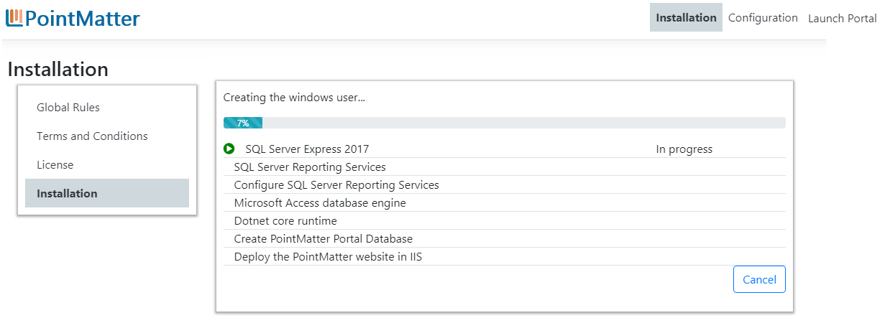

You’ll see a message that describes the progress and a confirmation message after the installation is complete.
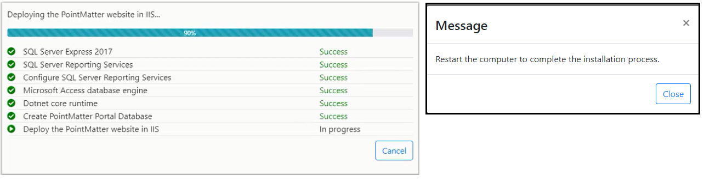

Step 7: Reboot your computer. After the reboot, run the PointMatter Installation and Configuration App again.

PointMatter Application Configuration
After installation PointMatter Reporting Services is ready for configuration.

Alerton: There is a bug in the installation. When the program starts again after a reboot, click on “Configuration” in the top menu to continue.

You will need to configure the following items. Detailed instructions are on the following pages.
- Tenant Configuration
  - Tenant Setup (Alerton: this is the repjob information)
  - Source Setup (Alerton: this is the Compass DB location and read-only credentials)
  - Gateway Setup (Alerton: this is the IIS setup information to access PRS)
- SMTP Configuration
- Portal Configuration

Important: Required Privileges
During the configuration of PointMatter you will need to have access to a user account which has sysadmin permission on the SQL SERVER used by Compass.
This installation of PointMatter will create a service user on the Compass database called "pmuser". This account requires read-only access to the Compass Database.

Tenant Configuration

Tenant Setup
- The first time you run the PointMatter installation, this screen will show a message stating “No Tenant is configured”
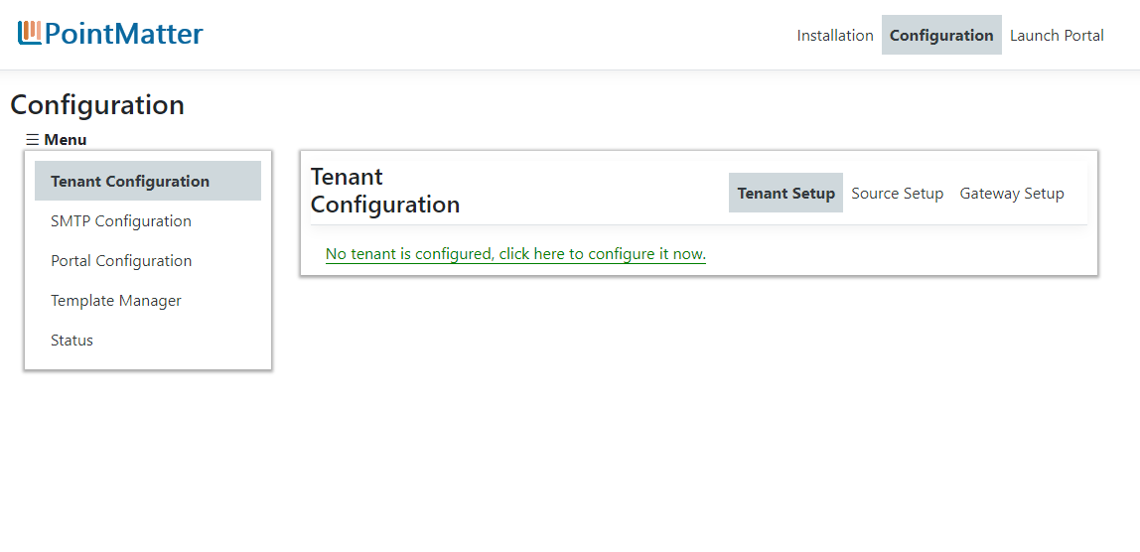

- Click on the message link to add the Tenant
Alerton: Note, for this version we only allow a single tenant (or site). We will support multi-tenants in the cloud and on-prem

You will be prompted for Administrator credentials to continue
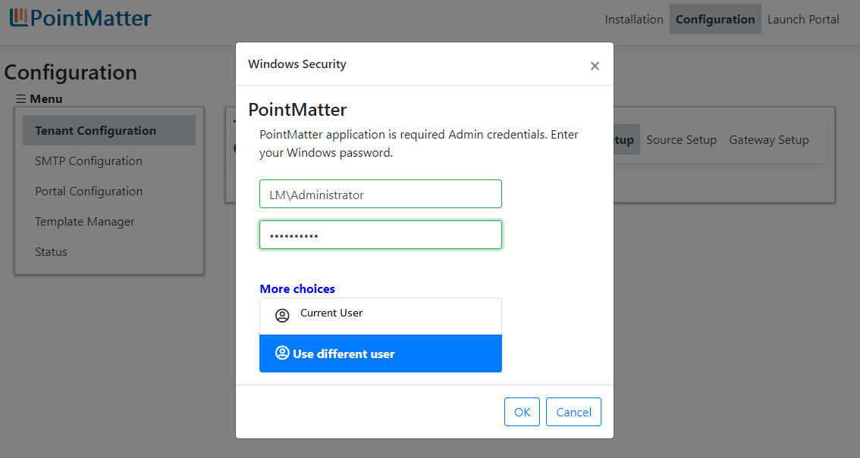

The installation app will verify that SQL Server (PMEXPRESS) Service and SQL Server Reporting Services are running
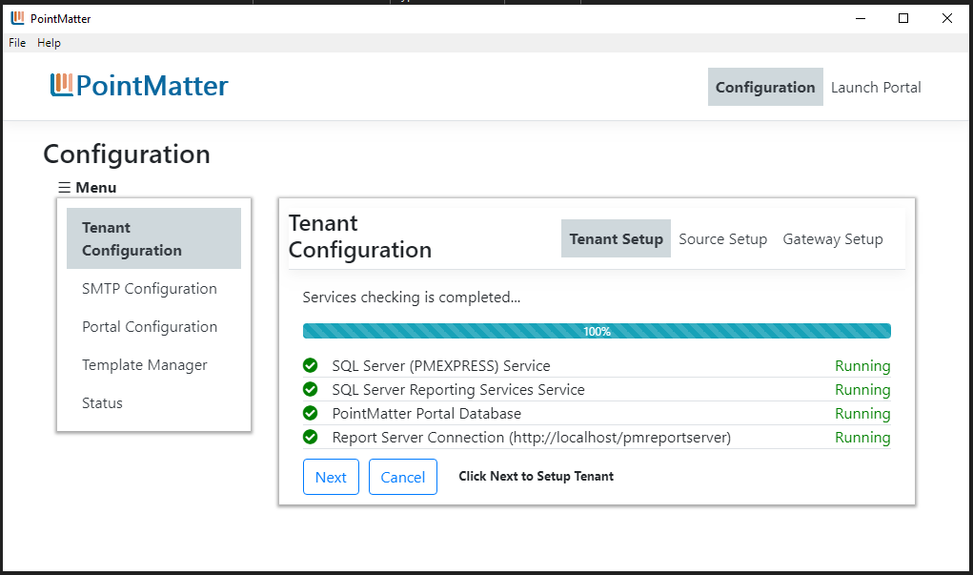

If any of the services are not in Running state, a failure message with troubleshooting steps will be displayed.
Follow the steps to restart the services and click on the Recheck button to verify the services are running.

- Provide Tenant name and click on Create Tenant button
Alerton: You can use any name for the Tenant Name. In the future we will have multi-tenants.

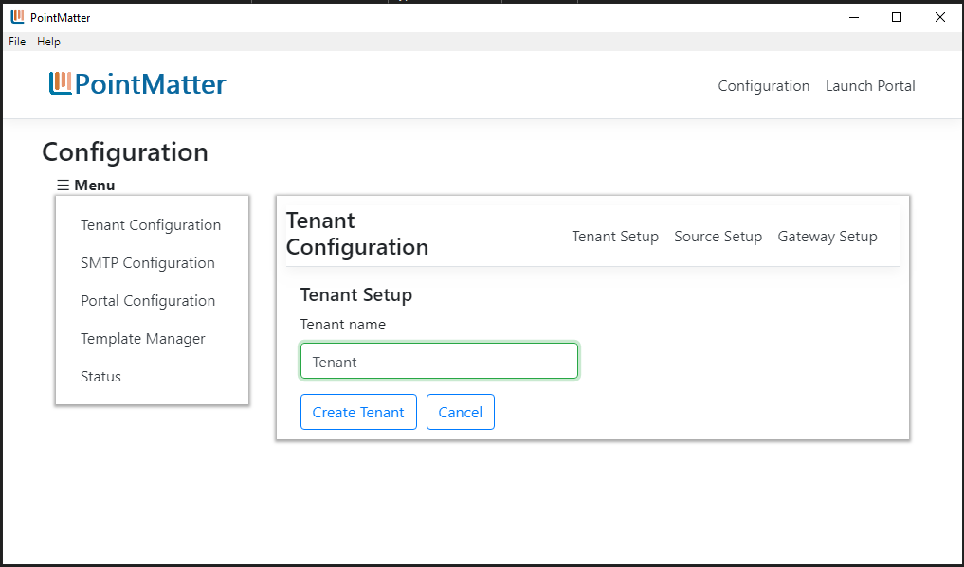

The following steps are now done
- Create and Operational Data Source and Analytical Data Source in SQL Server (PMEXPRESS)
- Deploy the PointMatter Apps and SLA Reports templates
- Setup the PointMatter Gateway and create PointMatter Gateway tasks for scheduled data gathering

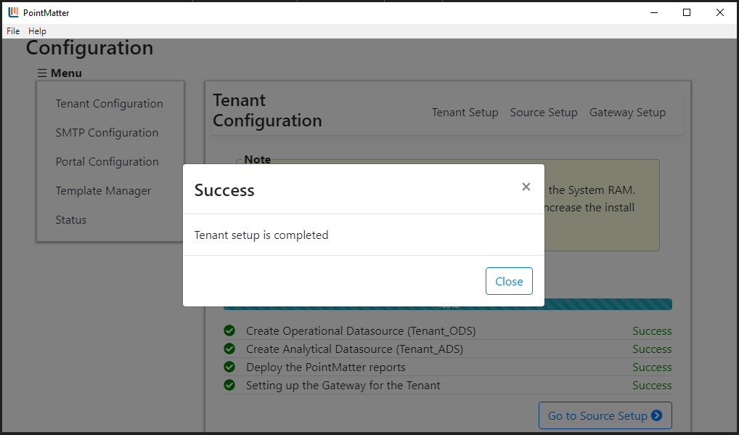
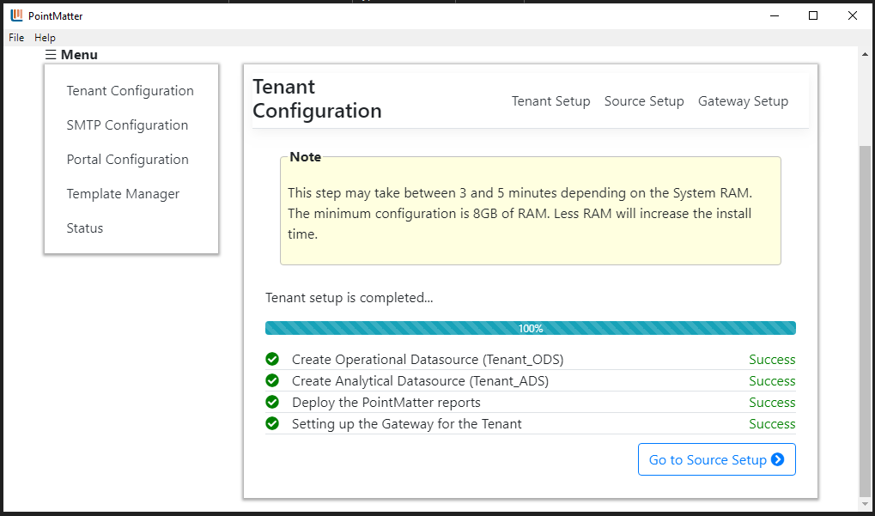

Source Setup
[Please read Required Privileges section before performing this configuration]

Alerton: you will need a sysadmin account on the Compass SQL Server computer

In this step you will configure the connection to the Compass database.

Note: you will need to scroll the screen down to see each step.
Step 1: Select the Source Connector type and Tenant from respective dropdowns
Alerton: Select “Alerton Compass Database” and the Tenant name you previously entered.
Step 2: Provide the folder location of the RepJob, Rep name and Job name for the selected tenant.
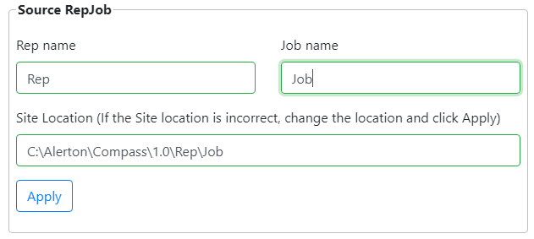
Alerton: This is the location for the Compass Repjob. Enter the path if it is different from the default given
Step 3: Provide the required Database Authentication information
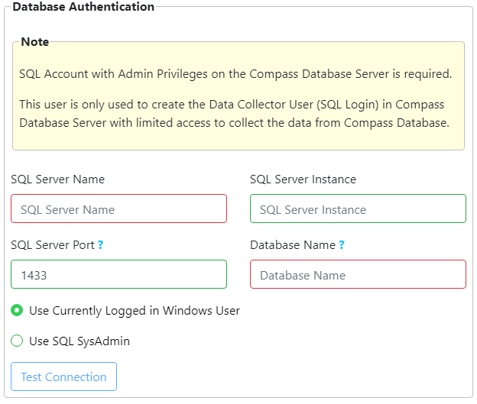
Alerton: If the Compass SQL Server is on the same machine, enter a “.” (period) for SQL Server Name and do not enter anything for SQL Server Instance. You will need the SQL port and the Compass database name.
Step 4: Test the database connection with the Test Connections button. If there is an error connected, check the data you entered and retry.

Step 5: The last step is to create the Data collector user on the Compass SQL Server.
Option 1: Windows Authentication
If the Compass SQL Server and PRS server are in the same machine please choose Option A,
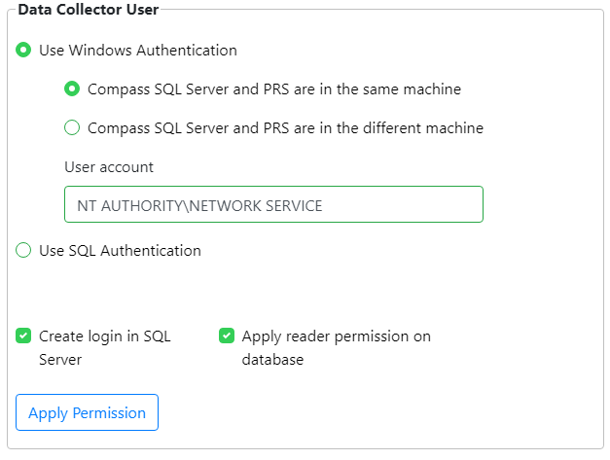
If the Compass SQL Server and PRS server are in different machines please choose Option B.
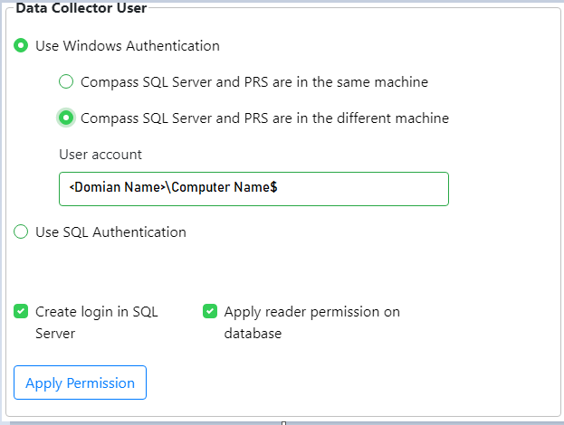
Then click on the Apply Permission button.
Option 2: SQL Server Authentication
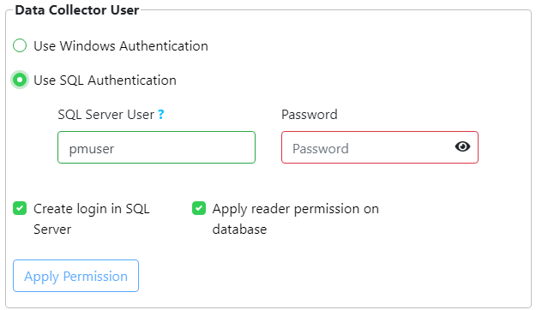
By default it is “pmuser”. You can change the name if you want. Provide the password, Then click on the Apply permission button to give required permissions to the Data collector user.

Gateway Setup
By default, the PointMatter gateway will collect data from the Compass SQL database every hour. In this step you can Run the data collection manually for the first time. This is not required but it is suggested. There will be no data in the PRS database until the gateway is run. It will run within the next hour if you do not complete this step.

“Priority History” means any data that is used within a PRS report. By default, PRS will not pull all trendlog and energylog data from Compass into its database. It will only pull the data that is being used in reports. PRS will always pull all alarm data.

We recommend you run the following when PRS is first setup:

- Send all config
- Send all device pointdata
- Send all alarm history
- Send all priority History

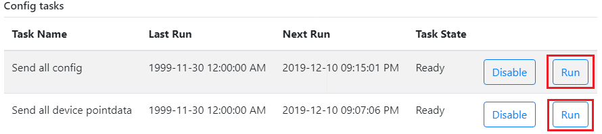

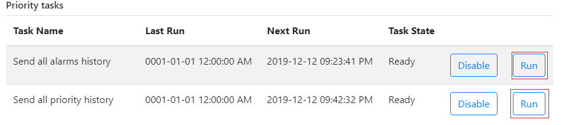

Alerton: Note that this section of the User’s Guide will be expanded.

SMTP Configuration
In this Step you will configure SMTP for outbound emails from the PRS.

Check the Enable SSL box if that applies to your organization

Step 1: Server Name: The Name of the SMTP server
Step 2: SMTP Port: Port used by the SMTP server
Step 3: Senders Email: Email address which will be used to send emails.
Step 4: Password: the Password used for senders email, to authenticate the email server.
Step 5: Click on “Save” to save these configurations
Step 6: Test Email: Provide a Recipient email ID to send a test email to, and click on “Test mail” - this will authenticate the sender on the SMTP server and send a test email to the recipient.

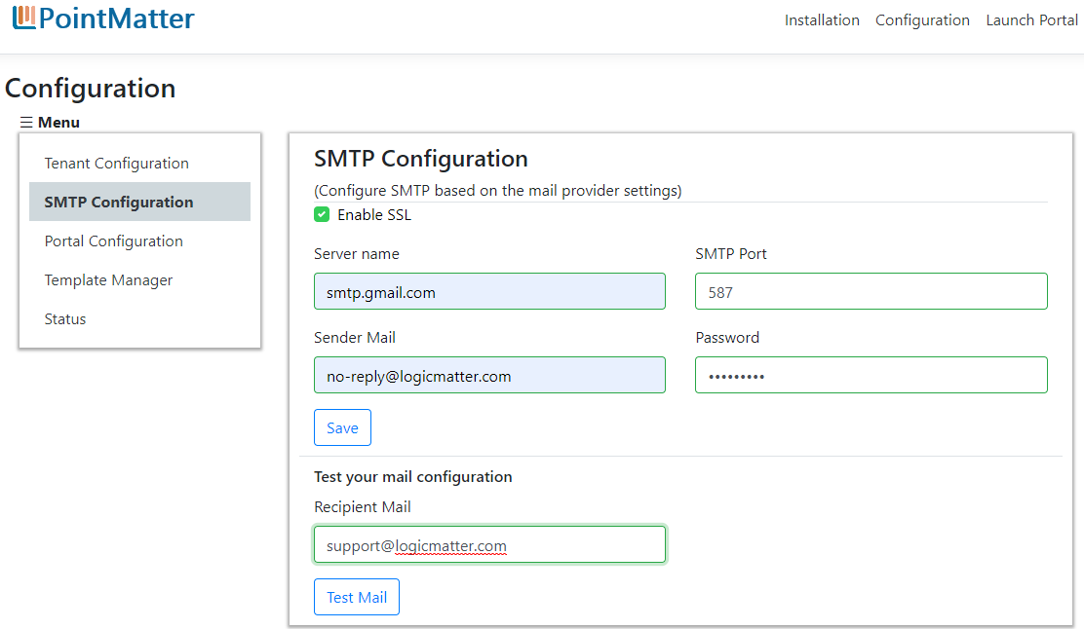

PointMatter Portal Configuration
In this step, you need to provide the HTTP PORT on which the PointMatter portal site will be running and accessed from.

The default port used by PointMatter is 88.

Step 1: Provide the port number or use the default port 88
Step 2: Click on the “APPLY” button

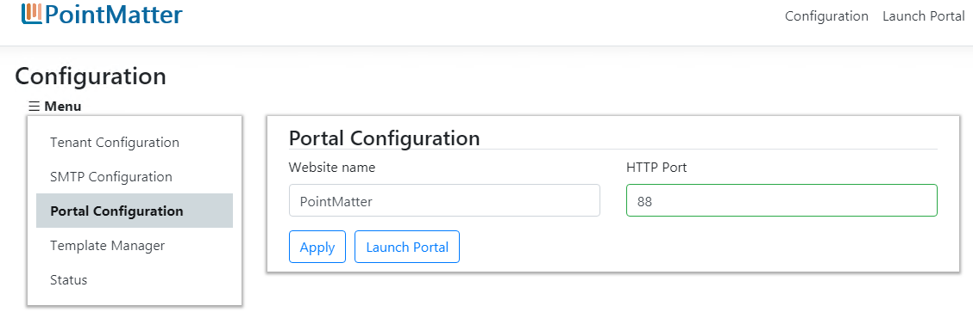

Click on Launch Portal to open PointMatter web portal

You are not done with the PointMatter installation.

Click on “Launch Portal” to start PointMatter Reporting Solution.

Alerton: You will need a username and password to use PRS. These are listed in the credentials.txt file, included in the root directory of the distribution. For this release of the documentation we include them here:

Username: pmmanager@pointmatter.com
Password: pmmanager@$23

Refer to the User’s Guide to use PRS. You can use the Installation and Configuration program to modify or add templates (the next section).

NOTE: If the PRS does not launch right away, open Chrome and use the URL: localhost:88. This will launch the application.

PointMatter Template Manager
PRS provides administrators of the PRS system tools to
- Configure the default Template parameter such as
  - Header and Footer images and background color for each report created by PointMatter to have company logo and company colors.
  - The Schedule file repository location where all the scheduled reports will be stored for reference, archival and audit purpose
- List all PointMatter report templates and download the template RDLs
- Install, configure and deploy custom templates for each app that supports additional templates.

Template Configuration
In this section, users can configure the Report logo, background and color of Header and Footer applied at the time of exporting the Reports as PDF for the Tenant. User can configure

- Report header/footer image - Image that will appear on each report, ideally its LOGO for the tenant.
(ONLY PNG format is supported and image size limit less than 1MB)

- Report header/footer background-color

- Report header/footer font-color
Note By default PointMatter logo with blue background color and white font color will be reflected in all the reports(PDF), if you want to customise the logo please click on the Edit Config button and change the logo and colors.

- Scheduled Reports File Path - Location, where scheduled report executed files(pdf & excel) are stored and can be viewed for the respective Report in PM Portal reports list
Note Allow file Read and Write permission to “pmserviceuser” on the Scheduled Report Files Path folder manually, if required.
If there is no path is provided, application uses this default location to store files:
<drive>:\[Installation folder]]\ PointMatter\ resources \bin\wwwroot\ PmPortal\PmApps \dist\assets\files \downloads\file-schedules
Step 1: Click on Edit Config button
Step 2: Browse png image(less than 1MB in size)
Step 3: Click on background color input to select preferred color
Step 4: Click on font color input to select preferred color
Step 5: Provide a folder location in the “Scheduled File Location”
Step 5: Click on Save

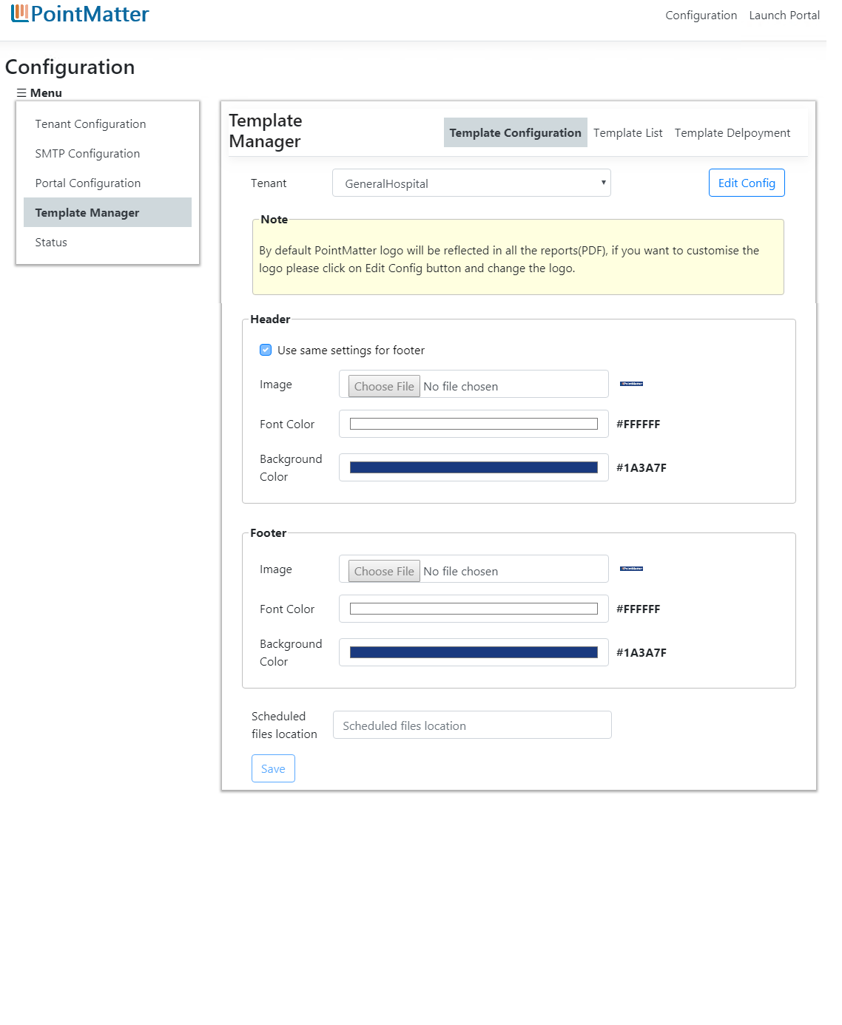

Template List
All the available Templates for the Tenant are listed in this section
To download a Template RDL file, click on Template name. This will download the .RDL file on the local system.

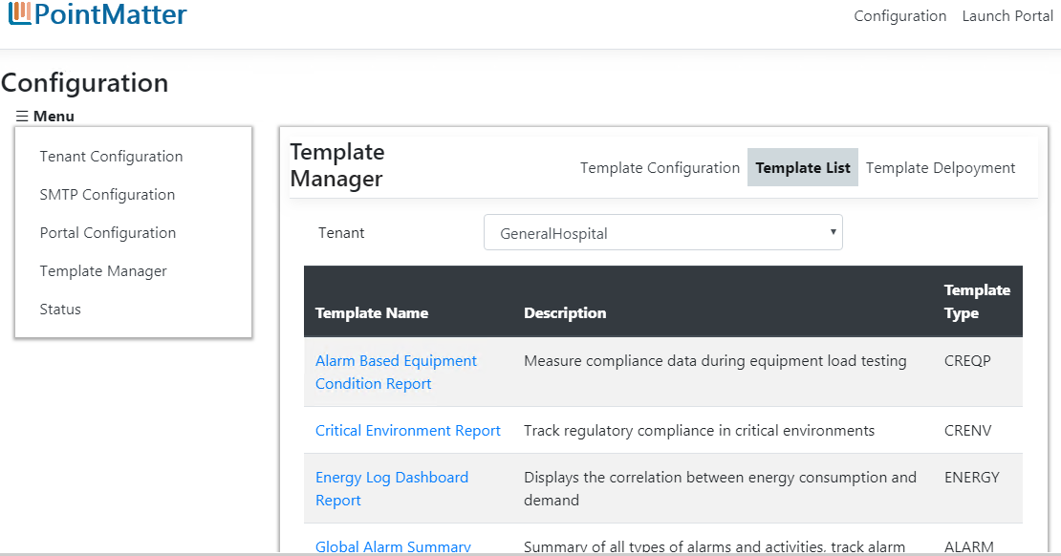

Template Deployment
You can upload a new Template or override the existing Template in Template Deployment section

Step 1: Select Tenant

Step 2: Choose a Template (file extension must be .rdl)
- Template file is validated as per PRS Template Standards.
- Templates must be one of the PRS App Types templates (crenv, creqp, alarm, trend, energy) any other template type is not allowed to deploy.
- Template Name (RDL file name) and Description is read from RDL parameters.

Step 3: Click on Deploy button

Step 4: Provide Windows Administrator credentials to deploy a template

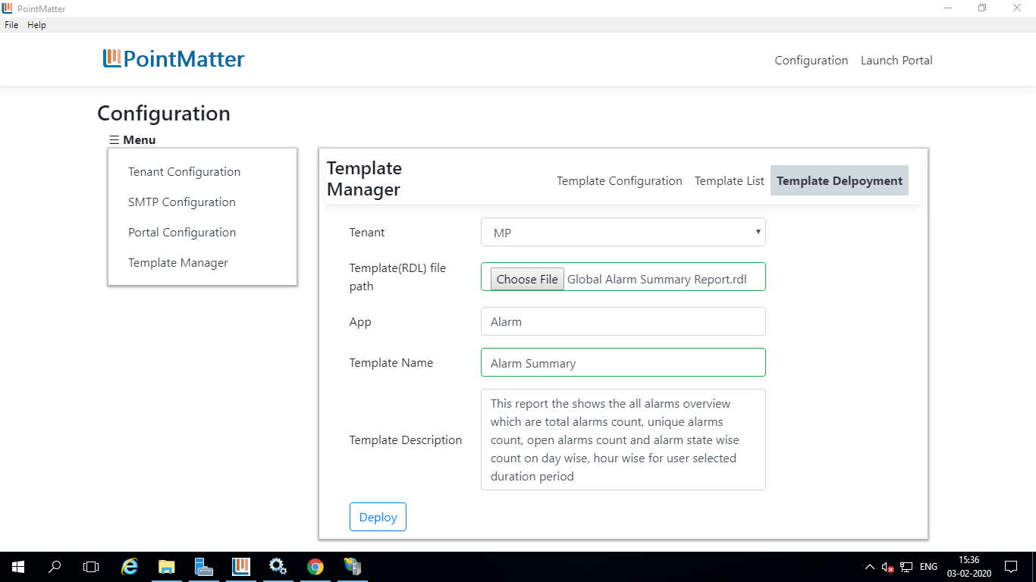

If the Template already exists in PointMatter then application will prompt user that if user wants to overwrite the existing template or create a new template with different name
- To overwrite the existing template - click on yes to override the existing Template
- To create a new template with a different name - Click on cancel and provide other name to deploy

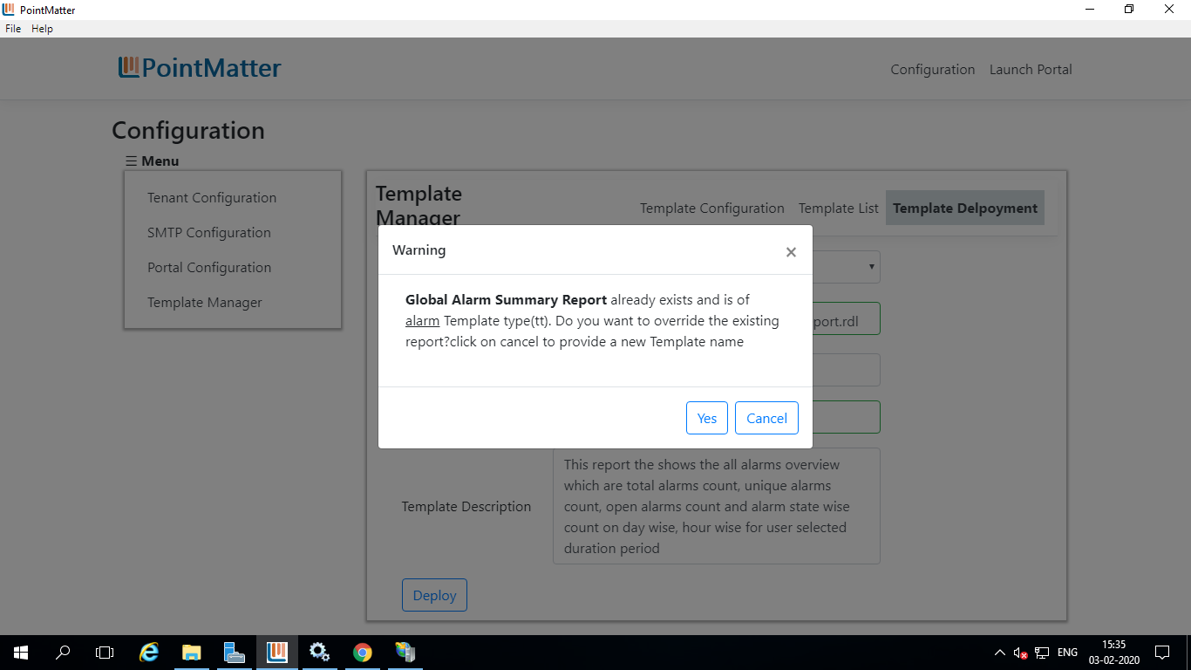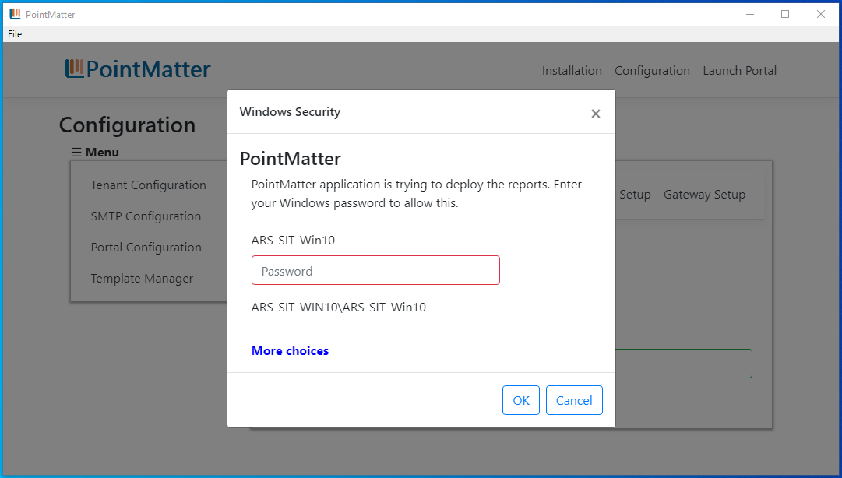

Status
PointMatter application requires it’s dependent services status Running, which are installed as prerequisites during Installation and Configuration of PointMatter.
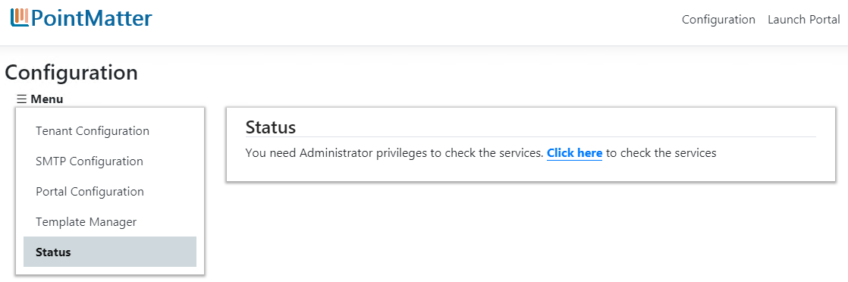

Click on the link Click here to provide Administrator credentials to know the services state
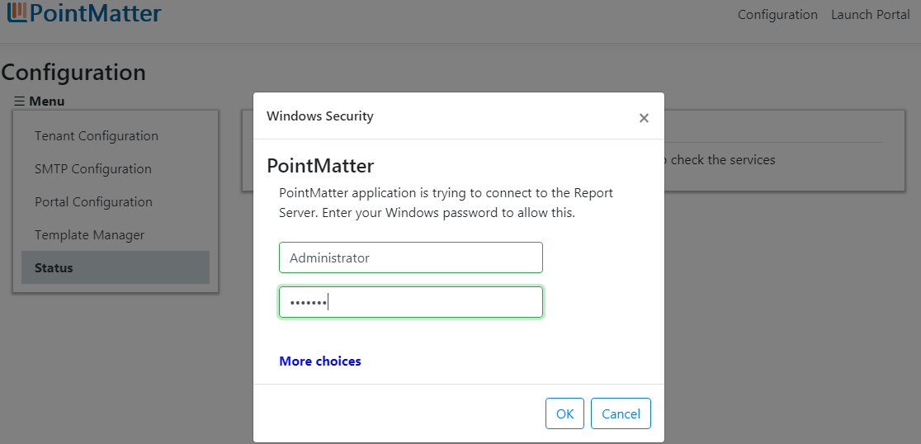
The services status is shown as below
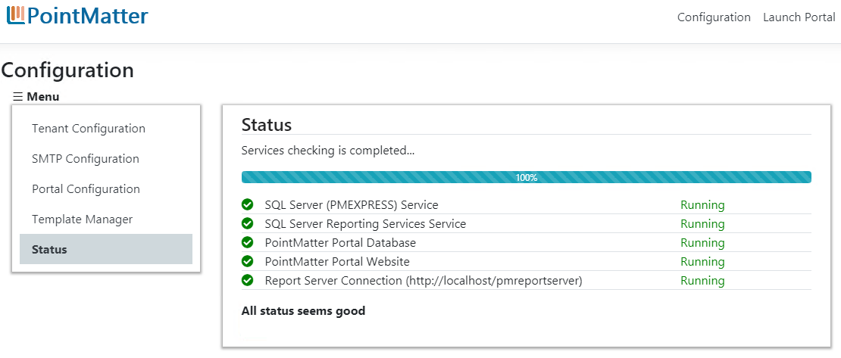

If any service status is not Running or Stopped, click on Stopped link to view and follow troubleshooting steps to start the services, and then click on Recheck button to re verify the status.
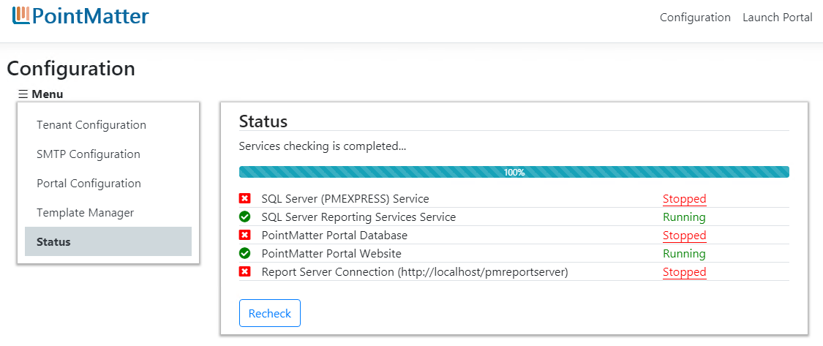
Still the issue persists, please contact LogicMatter Support

Appendix

System requirement for PointMatter version 1.0
PointMatter is available in English all included in a single installation. For support information please email supoprt@logicmatter.com

PointMatter Installed Side by side to Compass Server
Server to Host PointMatter
Component | Minimum requirement
Operating System | Windows Server 2016 (Rec)  Windows Server 2012 R2 (64 bit)  Windows Server 2012 (64-bit)  Windows 10 (Pro/Ent)
Browser | Chrome: latest version
 | NOTE: PointMatter is designed, developed, and tested to function best using the Chrome browser. Other browsers may be compatible; however, LogicMatter strongly recommends Chrome.
Web Server | IIS 8.0 or later
Hardware*
 | Based on the recommendation of the Compass Server Minimum system requirement
Software**
Microsoft .Net Core Runtime - 2.2.7(x64)
Microsoft .Net Core Runtime - 2.2.7(x86)
AccessDatabaseEngine_x64
Microsoft SQL Server Reporting Services 2017
Database | Microsoft SQL Server Express 2017
COMPASS SOFTWARE
Version | 1.5.x or 1.6.x
*COMPASS Server (version 1.6.x)
Compass Model | Operating System | CPU Cores*** | Memory***
COMPASS-1-ENT | 64 Bit System | Eight-core | 32GB
COMPASS-1-XL | Windows 10 (Pro/Ent)  Windows 7 (Pro/Ent)  Windows Server 2019  Windows Server 2016  Windows Server 2012 R2 | Eight-core | 16 GB
COMPASS-1-LG |  | Quad-core | 16 GB
COMPASS-1-MD |  | Quad-core | 8GB
COMPASS-1-SM |  | Quad-core | 8GB
*COMPASS Server (version 1.5.x)
Compass Model | Operating System | CPU Cores** | Memory***
COMPASS-1-ENT | 64 Bit System | Eight-core | 32GB
COMPASS-1-XL | Windows 10 (Pro/Ent)  Windows 7 (Pro/Ent)  Windows Server 2012 R2 | Eight-core | 16 GB
COMPASS-1-LG |  | Quad-core | 16 GB
COMPASS-1-MD |  | Quad-core | 8GB
COMPASS-1-SM |  | Quad-core | 8GB

*** CPU Cores and Memory recommendations are minimums – increasing the number of cores and the amount of memory improves performance and provides for better user experience.
** PointMatter installer will install these on target systems if already not available. Microsoft SQL Server Express 2017 and Microsoft SQL Server Reporting Services 2017 will be always installed by PointMatter installer

PointMatter Installed on a Standalone machine
Server to Host PointMatter
Component | Minimum requirement
Operating System | Windows Server 2016 (Rec)  Windows Server 2012 R2 (64 bit)  Windows Server 2012 (64-bit)  Windows 10 (Pro/Ent)
Hardware
Processor*** | 64-bit, 4-core Processor
Memory*** | 16 GB
Storage | 120 GB for system drive
Network | IPV4
Browser | Chrome: latest version
 | NOTE: PointMatter is designed, developed, and tested to function best using the Chrome browser. Other browsers may be compatible; however, LogicMatter strongly recommends Chrome.
Web Server | IIS 8.0 or Later
Networking | TLS 1.2
Software**
Microsoft .Net Core Runtime - 2.2.7(x64)
Microsoft .Net Core Runtime - 2.2.7(x86)
AccessDatabaseEngine_x64
Microsoft SQL Server Reporting Services 2017
Database | Microsoft SQL Server Express 2017
COMPASS SOFTWARE
Version | 1.6.x or 1.5.x  1.5.x
*** CPU Cores and Memory recommendations are minimums – increasing the number of cores and
amount of memory improves performance and provides for better user experience.
** PointMatter installer will install these on target systems if already not available. Microsoft SQL Server Express 2017 and Microsoft SQL Server Reporting Services 2017 will be always installed by PointMatter installer

Web Server(IIS) Role Services

General Requirements
Common HTTP Features | Default Document
 | Directory Browsing
 | HTTP Errors
 | Static Content
 | Default Document
Health and Diagnostics | HTTP Logging
Performance | Static Content Compressions
Security | Request Filtering
Management Tools | IIS Management Console v8.0 or later

Account Requirements
Account | Purpose | Requirements
Setup | Use to install and configure the PointMatter software | - Local administrator on the server on which PointMatter will be installed.  - SysAdmin on the SQL instance containing the Compass database
Email address | Used as the "From" address for email notifications from PointMatter | An outbound SMTP server

Desktop Client
Client Desktop
Component | Minimum requirement
Desktop software
Operating System | Windows 7/Windows 8.0 (32/64-bit)  Windows 8.1 (32/64-bit)  Windows 10 (32/64-bit)
Browser | Chrome: latest version
 | NOTE: PointMatter is designed, developed, and tested to function best using the Chrome browser. Other browsers may be compatible; however, LogicMatter strongly recommends Chrome.
Hardware
Memory ** | 4 GB
Storage | 50 GB on System drive

**Memory recommendations are minimums – increasing the number of cores and the amount of memory improves performance and provides for better user experience.

List of Prerequisites
 | Prerequisite | Comments
1 | MS SQLExpress 2017 | Installed Always by PointMatter Installer
2 | MS SQL Server reporting services 2017 | Installed Always by PointMatter Installer
3 | MS Access Database engine | Installed by PointMatter Installer, if not present on the target system
4 | Microsoft .Net Core Runtime - 2.2.7(x64)
5 | Microsoft .Net Core Runtime - 2.2.7(x86)  (for 32 bit systems)

Enabling Internet Information Services (IIS)

Enabling IIS on Windows 10
The steps are explained with images for the easy understanding of the users.
Kindly follow the below steps.

1. Go to Start Menu and search for Control Panel. Open Control Panel.
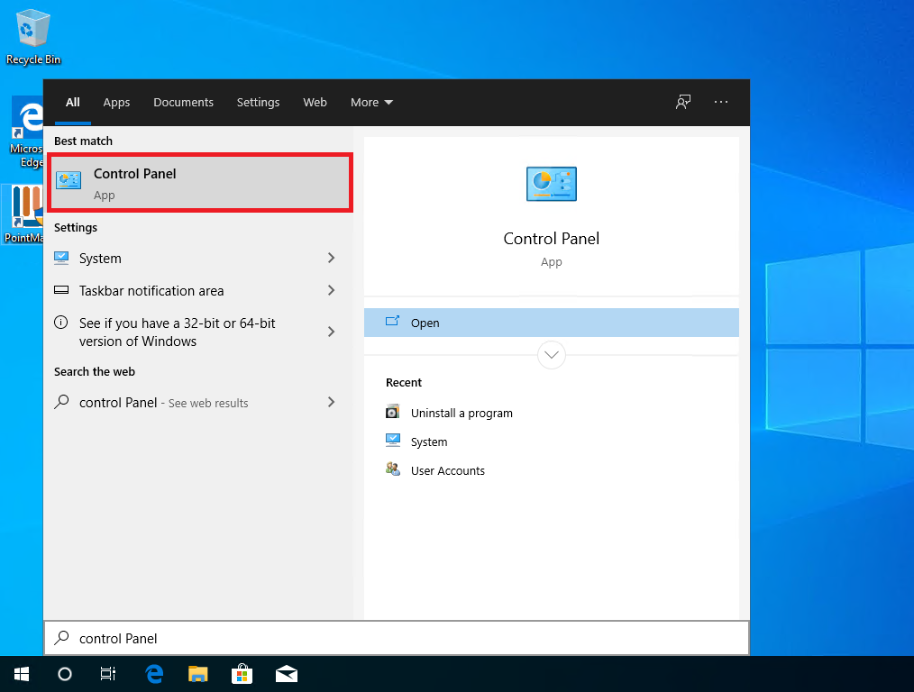

2. Click on Programs.
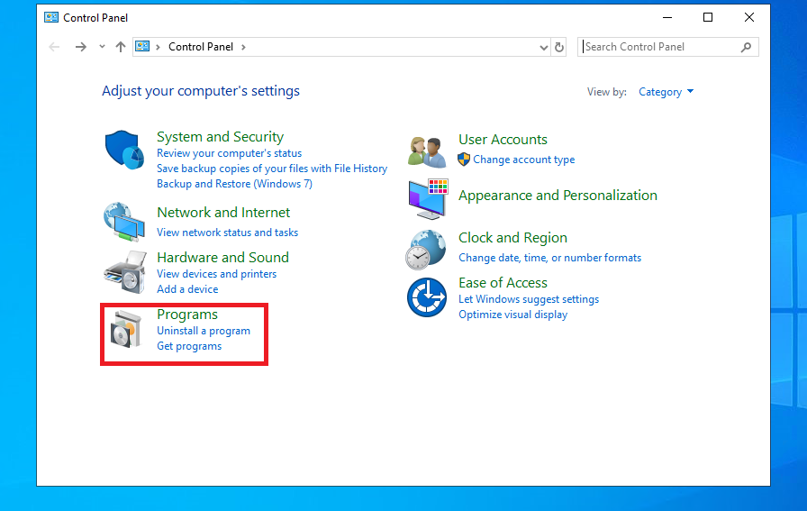
3. Now, proceed with “Turn Windows features on or off“.
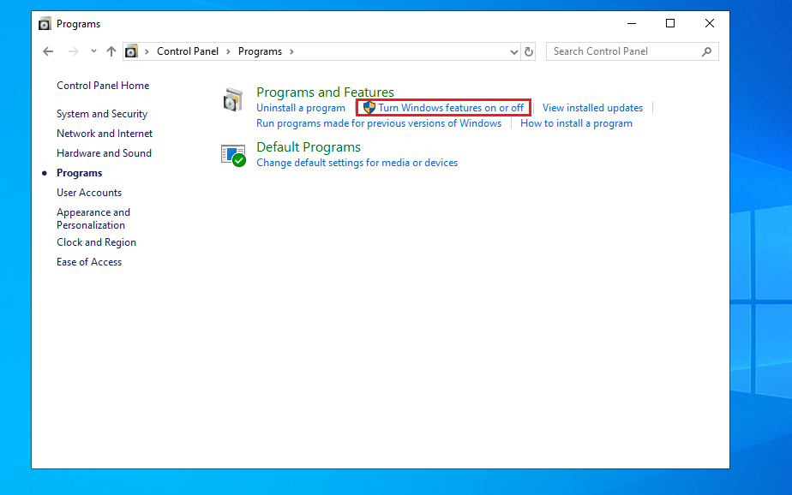
4. Windows Features dialog box will appear now.

5. Locate Internet Information Services and enable it.
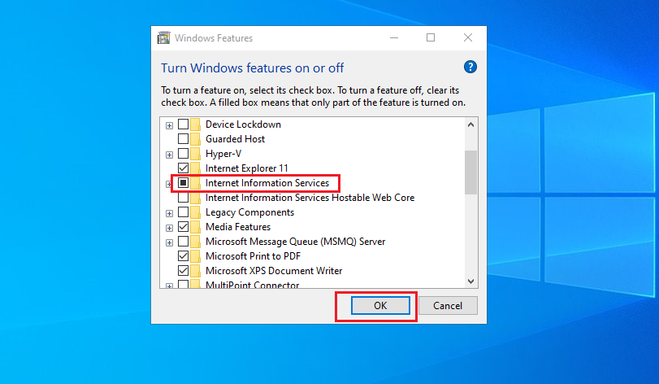

6. Finally, Click on OK.

7. Windows will search for the required files.

8. Finally, it will apply the changes and complete the requested changes. Click on Close.

Enabling IIS on Windows Server 2012 and 2016
Please follow the below Microsoft URL for enabling IIS on Windows server 2012 and 2016
https://docs.microsoft.com/en-us/iis/get-started/whats-new-in-iis-8/installing-iis-8-on-windows-server-2012

